The London Ambulance Service Benevolent Fund

Date: 17th November 2021 Time: 10:00 – 14:00

Annual General Meeting – AGENDA

Attendees. Apologises
Andrew Hall (AH) Debbie Richmond (DR)
Tina Vince (TV)
Christine Tanner (CT)
Kay Robson (KR)
Jackie Phipps (JP)

- Welcome Meeting open 10:00
AH opened the AGM at 10:00, welcoming everyone and thanking them for attending, DR apologised that she could not attend as she had been called into a short notice meeting. AH explained that as usual he’ll try and type notes as we discuss thing. Opportunity was given for someone else to take the minutes but no offers came forward.

- Minutes from last meeting held on 26th February 2021,
AH asked it everyone was happy with the minutes from the previous AGM in February 2021 All agreed that they were an accurate reflection of what was discussed and said. AH to sign them off and publish them. It was agreed that there was nothing to be kept confidential.
Action:- AH to publish the 2020 AGM minutes

AH went through the outstanding Actions from the previous AGM. There were a number of outstanding actions from the 2019 AGM and some from actions from the 2020 AGM;

- Outstanding Action: from 2019 AGM minutes

  - AH to double check the signatories at the Bank – Action completed
JP and TV believe that Lisa Wilkins had been removed from the signatories- AH asked whether any more signatories were required, it was felt that due to the way the banks are operating because of Covid we’ll leave of adding any more signatories for a while.

  - Committee members to check they have access to the Benevolent folder on the X Drive – Action completed
All Committee members confirmed they had access to the folder on the ‘X’ Drive. TV confirmed that she did not have can’t access to the database. AH believes that TV does not have MS access installed on her laptop.
Action:- AH to check next time he visits.

  - All members to read the Constitution and Bylaws to see if there are any changes needed.
The separate meeting has not been arranged due to Covid.
Action:- CT offered to look through the constitution and the bylaws and update where needed

  - DR to Email out the leaflet to all Clinical team leaders and also add in to staff trays at the stations that she visits. DR not at meeting unable to check

  - AH and TV to put a piece in the RIB about the fund Action completed
Action:- Needs to be done regularly.

  - AH to contact Mark Curtis to get him to put a comment on LIA about his recent visit to the Lodge. Action completed
Mark Curtis has left the LAS. No further action required

  - Next committee member to go down to measure the blinds in the bedrooms that need repairing so we can buy new ones.
Action:- CT to check when she goes down beginning of December
  - The internal work at the lodge was done but concern was made into the mirrored wardrobe door in one of the bedroom
Action:- CT to check when she goes down beginning of December

- Outstanding Action: from 2020 AGM minutes

  - TV or AH to contact Katy Crichton about ensuring the Fund is part of the Wellbeing hub thinking. – Action completed
TV Spoke to Katy about the wellbeing hub referring staff to the fund. TV has a weekly meeting with Katy and the wellbeing team. So has opportunities to regularly promote the fund and to ask ant question we may have.

  - AH to contact training School to ask about New Recruits and what they are told about the Benevolent fund – Action completed
- AH contacted training school but was advised that they do not have any part in that part of the training, and referred AH to LEAP department. AH to contact LEAP to discuss
– CT informed that resources will be recommencing their new entrance talks. CT is to update the information/ leaflet that they hand out so will put a bit into the leafltet about the Fund.
Also see Advertising about posters in training school

  - TV to think and draft a message to put in the RIB As people have not seen or heard from Tina they think she has left. Action completed

  - All to continue to promote with in their own departments and contacts – Action Ongoing
All confirmed that they were doing this and will continue to do so
– feedback from the lodge to go on to the website
Action:- AH to update the website

  - KR to Contact Admin staff and ask them to ensure that the Poster is displayed on station. Action completed
Action:- KR to re-contact admin with a new poster advertising the fund

  - TV to draft an advert to put in the RIB when we do the draw in March - Action completed

  - All to look at the Pulse and see what it says about the Fund, do we need to be change –
Action:- All to re-look at where we we feel the information about the fund should be positioned on the pulse –currently hard to locate and find any information about the fund. What information should be held on the pulse. We can then contact communications/ Pulse lead to see about updating the pulse -

  - AH to arrange a meeting with the Bank – Action completed
AH did contact the bank speaking with someone over the phone, However they were not very helpful and the request to speak with a business manager has not materialised. AH just wants to ensure that we are getting maximum return for our money and to change some of the current set up of the accounts, like only having £3000 in the current account. If money come in or goes out there is an immediate transfer of money from the saving account to maintain only £3000
Action:- AH will try again to get hold of a business manager,

  - All to look at the website and see if we need to change anything. Does it need updating in any way – Action completed

- Chairman’s Annual Report, - See Appendix 1
AH confirmed that it was his duty to prepared the chairman’s report which was sent our prior to the AGM to the committee members. AH took the opportunity to draw the committee’s attention to a number of points that he had written- See yellow highlighted sections o fthe chairman’s report in appendix’s 1. AH confirmed that the majority of points will be covered during the rest of the AGM?

TV confirmed that she still gets a requests and a number of referrals especially for loans but a lot of these requests are from staff who are not in the fund.

There were no questions resulting from the Annual report.

- Financial Administrator’s Annual report and Financial Analysis.
AH asked if everyone had a chance to look at the financial reports from the last two years, and also the slides that he produced showing he finances over the last 10 years (see Appendix 2)

AH put the finances on a power point to go through, as it showed a better understanding of what was happening.

Slide 1
AH explained that this slide showed the financial statement prepared by the accountants. AH observed and stated 2 things that sticks out about the finances
- the decrease of £25,000 of overall funds over the previous year
- The decrease in Subscription.

Slide 2
AH explained that Slide 2 shows a bar graph of the total money owned by the fund over the last 10 years. AH stated that in isolation it may seem like an awful loss of £25,00, however when you take into account the overall fund over the last 10 Years you see the ebbs and flow of the our finance and a final balance of £625,404 is still a healthy balance. But we should not be complacent.

Slide 3
AH the showed a slide showing the decrease in subscriptions over the last 8 years. AH said that when you add into the mix an ever decreasing subscription to a loss of £25,000 then we need to take note, AH don’t think we need to panic just yet or talk about closing the Fund, but we do need to take serious notice of what is happening and to try and stop the rot.

AH the said Lets just go through the finance in graph form as he thought it illustrates things better.

Slide 4
AH explained that the table in slide 4 represented the different areas of finance. (Income, expenses). This is just the table and not really that easy to see the trends but it give the figures.

Slide 5
AH explained that slide 5 could look like a confusing graph, as it represented all the information on it. However it does allow you to compare the different parts of the finance and see the trends.
For instance
Total income declines at the same rate as subscriptions (Yellow and Grey)
Loans (orange) and subscriptions (grey) both decline.

Slide 6 – Total Money
AH explained that this slide was the same one as slide 2. Here is the total money of the finance again. You will see that 2021, 2017 & 2011 are roughly the same. So if the pattern follows then we would increase again, however in 2017 we had a high number of Deaths, paid out for a new website and had a prize draw to celebrate 50 years in 2016. So the dip in finance in 2017 is a red herring. This shows that the finances are in decline.

Slide 7 - Subscriptions
AH showed stated that this slide shows where one of the issues lies. We have been taking about this for a number of years and we will discuss it further in a little while. The number of Subscriptions/Members are declining and we need to try and stop this and to increase our membership.

Slide 8 - Loans
AH said, again this slide demonstrates another issue, do the members realise that the fund offers interest free loans for members going through hardship or are there not as many members going through financial hardships as their predecessors. TV to comment on Loan enquiries in the next section. TV commented that this is a benefit that we need to advertise.

Slide 9 – Deaths
AH confirmed that it is always tricky to estimate how many death grants we will pay-out each year. Obviously the last 2 years have been exceptionally worse due to Covid but he would say the average is 3 a year on these figures.

Slide 10 - Retirements
Again when it comes to retirements AH stated that it is also a tricky one to predict, we had plato’d a bit following the mass exodus after the Olympics and the constant restructures, however this this last year we have seen a rise and this may be due to Covid. Currently about 27% of Members have been here over 20 years with 2% over 40 years. So we could predict that about 20% may retire over the next few years.

CT mentioned that at the minute 200 staff a week are being moved to leavers on GRS this is primarily non-payroll staff like 111, bank, fireman and agency staff. Lots or these are not in the fund as they were here only temporary.

Slide 11 – Dane Park Lodege expenses
By far our biggest asset is the lodge but it is also a constant expense. AH confirmed that the figures shown on this slide is for the expenses and does not include the depreciation value. Which is £5317 a year. AH stated that we are now charge £141 per a visit by shorefields to clean and get ready for the next members. Site fees are about £6500.

The year 2020-2021 we were not allowed to use it but despite this and the number of discounts for services provided by Shorefields we still spent £10,459 on it some of this was for repairs and new furniture.

As part of the Covid response Shorefields were testing/swabbing after each clean, this was being provide free. The last results that TV received were in august, the committee decided that there was no need to continue with the swabbing/testing or to chase Shorefields up about it.

Slide 12 – Comparison
AH confirmed that this slide was as stated as comparison between, total income, total expense, total money and subscriptions. From the slide we can easily see that the decrease in subscriptions in in direct proportion to the decrease in income represented, and this along with an increase in expenditure has a direct coloration to the total money

AH asked if there were any questions on the finance, there were no specific questions although TV stated that this year again seems that we have had an expensive year buying things for the lodge with new duvets, pillows etc.

- Assistance Advisor / LAS Staff Support Advisor / General Comments on Funds current activity and future within the LAS.

AH then invited the Assistance Advisor (TV) to make any comments on the fund, and also asked, “Are you still getting many enquiries about loans?”

TV said that most of the comments about the fund have already been made. She thanked the committee and the chairman for their support and help over the year especially replying to the emails and loan requests. TV concluded that without it then she would not have been able to do what she has done.

In terms of enquires TV confirmed that she is still getting lot of enquiries about loans howbeit not as many as she used to, but the majority of these staff are not in the fund. She refers them to the website.

AH suggested that when she replies to them that she attached the joining forms.

Action:- AH to send TV the joining forms so she has them on her laptop, to send them to the staff that request. Action completed
There was also confirmation that International students are not advised about the fund when they join?

- Chairman and Executive Committee membership for 2021/2022

AH showed a slide demonstrating the current committee members
Slide 13 – Committee members

Current Executive Committee
 |  | Elected | Re-Elected | Re-Election due
Chairperson: | Andrew Hall | Jul-15 | Sep-18 | Jul-21
Deputy Chairperson: | Christine Tanner | Sep-18 |  | Jul-21
Assistance Advisor: | Tina Vince | Neither Tina or Jackie are elected as per the constitution and by laws
Financial Administrator: | Jackie Phipps
Executive Committee: | Andrew Hall | Jun-11 | Sep-18 | Jul-21
Executive Committee: | Christine Tanner | Nov-14 | Sep-18 | Jul-21
Executive Committee: | Kay Robson | Oct-19 |  | Oct-22
Executive Committee: | Debbie Richmond | Oct-19 |  | Oct-22

As mentioned last time both CT and AH term as Executive Committee members were due in July 202. AH believes that officially the fund members ought to have a say on whether they should be re-elected to run the fund. However in light of the fact that members do not get in touch or ask questions, then it is down to the fellow committee member to nominate and second whether they are to continue as committee members for another 3 years.

So first of all; Christine Tanner - Nominated JP - and seconded by TV
Secondly: Myself. Nominated TV – and seconded by JP and CT

Also the terms as Chairman and Deputy Chairperson are up for election.

AH asked would anyone like to nominate a chairperson, and can we get a second.
TV nominated AH and JP seconded it.
AH nominated CT as Deputy chairperson, and TV seconded it.
AH reminded the committee that Sue had left the LAS and therefore the fund, we are down to 6 committee members. AH once more expressed the need for new committee members? And asked how do we go about getting them? Is it by Recommendation of advertising? Do we re-contact those that offered up before?

Following a discussion it was decided that we do not need to re-contact previous members that had offered up, the best way forward was to Re-advertise in the RIB, - CT agreed to write a piece to go into the RIB asking for member to become part of the committee, Action completed.

TV thought that the committee is working well together and confirmed that Sue Kemp had been a good committee member promoting the fund by talking to staff and supporting them.

- Constitution and Bylaws

AH stated that we have been saying this for a number of years of the need to look at the constitution and bylaws to see if they are still in date? And if we need to update anything/change anything.

AH said firstly I think we need to know how/ whether can change things.
TV thought that as the consistution and bylaws had been written by the members then we could change them providing we are all in agreement.

AH then asked if anyone was willing to look into legally what we can and cannot do?
Action:- CT agreed to look into whether there is any legal notification that we need to do to change the wording and also CT agreed to look at the bye laws & constitution to bring them up to date. if anything needs discussing a meeting will be held.

- Benefits and Subscriptions. 2018/2019

Commenting about the benefits TV said that the lodge was our biggest asset and that no other benevolent fund or charity provides what we do in terms of a free holiday. AH said that this year the lodge seems to have been well booked up since we re-opened in May, Ah assumed that this was because we have had 2 years’ worth of members going down in one year?

TV confirmed that only one week has got cancelled due to covid.

AH said he still feels as if the Lodge is not utilised as much as it could we know July – September are generally booked up. But the rest of the year it is the odd week or two. This could be due to the decrease in members/subscriptions.

AH confirmed that we do have the condition that it you have benefitted from it once you can’t use it again. That said we have over the recent years allowed a number of members to reuse, given they are experiencing a new circumstance and it has been a number of years since there last visit.

Comment was made on the age of the lodge and AH confirmed that we have had it for 12 years – a discussion was then had about the age of the lodge which resulted in the decision to keep an eye on the maintenance of the lodge and if it starts to cost a lot to maintain it to its high standard then we will have to reconsider.

So far we have 3 bookings for next year.

In terms of the loans AH commented that as previously stated the number of loans are decreasing and so far this financial year we have had 6 loans totalling about £5000, last year there were 8 loans of £10,000.

AH asked as he has done each year “Is there any other benefits that we could offer to our members?”

The benefits we offer are, a prize draw, death grant, retirement’s grant, only fund that offer free respite, and interest loans.

TV said that in promoting the fund we should concentrate on the positives like the prize draw and the loans rather than

In terms of Subscriptions AH said we have seen that there has been a steady decline in the number of members.

The current database shows 1789 members. The following Table shows the spread of members according to the years they joined.

Year Joined | No. of members | %
1970-79 | 3 | 0.17%
1980-89 | 70 | 3.91%
1990-99 | 385 | 21.52%
2000-2004 | 348 | 19.45%
2005-2009 | 326 | 18.22%
2010-2014 | 260 | 14.53%
2014-2019 | 289 | 16.15%
2020- | 108 | 6.04%
Total | 1789

It was all agreed that we need to Promotion & Publicise the fund more.

- Advertising
AH asked How can we get new Members?

TV said we need to highlight the benefits like being entered into the draw imeadiately

AH confirmed he had spoken with the Education department and that during staff initial training they do not have responsibility for the corporate induction side of things including the benevolent fund. They believe is down to LEAP department. AH confirmed he has yet to contact them.

Action:- AH to contact them after a poster is created

A New Poster is needed highlighting the benefits -
Action:- AH to create a poster, and KR to send it out to all stations, education schools,
Action:- CT to put a message in the RIB

- Database
AH said that no more was need to be said about the database its working fine and kept up to date. It is on the ‘X’ Drive so all committee members can access it.

- Accountants –
AH is still not happy with them. We are paying them £3300 a year to do what? A few hours work, which he could do, what do they do. - AH asked if anyone had any contacts in accountancy to ask.
Action:- AH to look into an accountant to ask what we need to do legally?

- Banking - Cheques
AH confirmed we are still having a few issues getting cheque books but think we have solved it, he can now order online via a form and we have got the post redirected so that it is all coming directly to him instead of going via HQ.

AH confirmed he is in discussion with Rob Dawson Payroll manager about paying directly in to staff accounts for loans and draw winners. Rob seems to think that it should be fine but he just needs to check with the finance team.

AH stated his frustrations at trying to get a meeting with the bank but it was on the phone and not very productive as the person I was speaking to could not locate or access some of the accounts.

- Lodge
AH said that we have a couple of outstanding issues that we are trying to sort. The skylight in the lounge is leaking, and the hoover has stopped working? TV confirmed that a repair had been done on the skylight.

AH asked if anyone was free to go down and check everything out. CT confirmed that she could go down beginning of December. As the week that AH was free there was someone booked into the lodge?

AH asked KR if she had been down and she said no.
Action:- KR to look at some dates to go down to lodge.
JP asked about block booking weeks throughout the year for the committee member to go down. – JP can only go down in school holidays.

It was agreed that there was no need to do this as there were members that could go down outside of the school holidays to check on the lodge.

TV said that it was good if we could have a committee member to go down at the beginning and towards the end of each year, to check that things are working and to see what needs to be replaced.

- Website
AH confirmed that there were no issues with the website just needs to update a few photos
Action:- AH to update

- Conflict of interest
No-one had any conflict of interests.

- A. O. B.
  - AH asked TV about her Meetings with Katy Crichton –
Nothing further to add to the previous comments in outstanding actions

  - AH asked TV about her Meetings with Sally George head of charity –
TV confirmed that Sally initially enquired about a LASRA grant and didn’t didn’t know about the Benevolent fund. TV took the opportunity to inform her of the fund and what we do.

- Loans to staff who have been off sick with no unsocial or OT. On section 2,

Following a member stating on her application for a loan that she was in hardship because she had not received unsocial payment in her wages due to being off sick. CT questioned this. A discussion was held around the fact that All new staff since 2019 are aware that they are on section 2 and therefore do not get paid unsocial hours if they are off sick (unless it is work related) and as such need to account for this with their wages. CT asked would giving a loan in these circumstances open a can of worms. It was felt that the majority of the time we do not know which pay conditions members are on and therefore if a members say they are in hardship because they are off sick then a loan is given, providing they meet the criteria for hardship then we discuss and give the loan. Circumstances are looked at especially in making sure that they members can afford to pay the loan back and that the pay back is not putting them in more hardship.

We do need to be mindful that this doesn’t open a can of worms. Just because members don’t get unsocial payment for a month.

- Closing

AH asked is there anything discussed today that should not have been published? Everyone agreed that it could all be published.

AH closed the meeting at 12:23
Appendix 1

LONDON AMBULANCE SERVICE BENEVOLENT FUND
ANNUAL GENERAL MEETING FOR THE PERIOD
1st April 2019 – 31st March 2021

Chairperson’s Annual Report 31st March 2021
Well, what a different 2 years makes to the outlook of everybody. Firstly can I apologise that there was no chairman’s report in April 2020, Covid caused a number of issues, Staff working from home, departments being moved to new offices, staff not available etc, All of this upheaval caused a delayed in getting the financial report from the accountants. We only managed to get the financial report for the year 2019-2020 at the beginning of 2021. So the decision was made to combine the last two year in this Chairman’s report.
Whilst Covid in general has brought about its own pressures with staffing and resourcing, The LAS and the NHS continued to be constantly under severe pressure. The chief executive continues with his review and restructure of all LAS departments in line with his way of working and in the hope of saving £25 million and this along with the constant pressures and the problems of Covid continues to have a negative effect of staff morale in the LAS with it remaining low, staff continue to be despondent and a number leaving the service. So on the back of all that doom and gloom I write this report.
Despite all that is happening in London and the world it has reminded the staff and the public of how great the NHS is and what a wonderful job they do. It has been lovely to enjoy and feel part of the NHS during such times as the Thursday clap, and Sir Tom’s charity walks. This has been especially prevalent in the number of offers and freebies that continue to be given to the emergency services.
We are reminded that the Fund was set up to support its members and I’ve no doubt, that what has happened over the last year will continue to affect our members in different ways and the support of the fund will no doubt be called upon. However as I look back over the last two years, if our members have been affected in any way the support and benefits that we offer have not been as utilised as much as it could be. However we have seen a rise in the number of deaths in service and we offer our condolences to the members of family left behind.
As the Chairperson I continue to ensure that the fund upholds the constitution and by-laws it was set up on, and also seek to maintain a great financial position in order that we can continue to:
” provide support and assistance in the relief of severe but temporary financial hardship and/or unforeseen circumstances outside the control of the individual member of the fund or dependents that may be concerned.”
As the chairperson of the London Ambulance Service Benevolent Fund I am continually faced with surprises and challenges, but with the support of the executive committee I have been able to continue to lead the fund in the same manner that it has been since it was created. On a personnel note these last two year has been a major challenge for the fund as I have been required to undertake more of the admin and financial side of the fund due to the home working
of Tina and Jackie. That said we as the executive committee have worked our way through these problems to ensure that at all times the fund continues to run day by day to support its members going through hardship.
As we go forward into a new year I will seek to endeavour to support our members through their hardships and promote the Fund throughout the service and the benefits that we can give.

Chairperson’s responsibility in writing the report
The chairperson of the London Ambulance Service Benevolent Fund is the responsible person for overseeing the efficient and effective management of the fund and under the constitution of the Fund is also required to report annually on the performance of the Fund during the previous 12 Months, including the current position, and any foreseen or possible changes that may affect our members during the year ahead. In keeping with the above it is my responsibility to submit a report in preparation for the Funds Annual General Meeting, which has traditionally been fixed within our constitution to take place within the first Quarter of the year following the financial year being reported on.
As part of my responsibilities I am bound to provide a financial report on the fund covering the financial period, 1st April 2019 - 31st March 2021. This allows me to publish the Funds balance sheet within the prescribed time scale giving members an indication of the financial performance measured against the previous twelve month period. The full financial analysis will be discussed and ratified by the executive committee at our Annual General Meeting. The Annual General Meeting is due to take place within an approximate and predetermined period for each year. This can of course be delayed depending upon the amount of problems or normal difficulties that we regularly face.
The Annual General Meeting covers in its agenda various reports on our performance during the Funds previous financial year, (1st April to 31st March) plus any recommendations that may be required to maintain or improve the position or performance of the Fund.
The AGM will also consider the election or re-election of the management and executive committee as required under the constitution and Bye Laws of the Fund
The above preamble to the Chairman’s report explains the chairman’s responsibility, the reporting period and the management council and executive committee’s re- election and the implementation of any recommendations from the AGM.

Executive Committee
I say this each year and this year is no different, in fact if I’m truthful my concern has grown. One of my continuing concerns is the Executive Committee, since I have been part of the committee I have felt we need more Executive Committee members to help improve transparency and to plan for the future. In previous years we have struggled to find committed Executive Committee Members that are available to support as required.
The provision of support to our members in need is of a varying nature and sometimes demands immediate or urgent action and Tina Vince deals with all of this on a daily basis, usually at the time of the members greatest difficulty. Members that have dealt with Tina during their moments of crisis will witness to how they have been dealt with in a compassionate and committed way and were able to rely upon the Fund and the support offered in their time of greatest need. Tina Vince needs the support of the committee to approve loans and grants to
help the members. In order to continue this we need to have enough Executive Committee Member to support Tina Vince on a daily basis and we need to plan for the future for when she retires.
Despite this Tina Vince has continued to deal with bereavements, severe accidents, marital problems, loss of accommodation, hardship, severe financial difficulties, and so many other varied problems that the average person would be at a loss to deal with.
Once more I write that looking forward I see the need to continue to expand the executive committee in to geographical areas that have no representation, and adding members, even as far as doubling the current numbers. I as the chairperson have struggled at some points in the last year to keep on top of what is required of me as the chairperson and wish to ensure that the following years are not the same.
I do however wish to place on record my thanks to the Executive Committee for their continual support and hard work that they do for the fund, so often behind the scenes that they are not noticed.

How did we perform in the year 2019 / 2021
Financial
Having received the official financial report from the accountants I can confirm that the fund continues to have a steady and healthy financial balance. However it is in decline. For the year April 2019 – March 202 we decrease by £11,087, this year has been no better with a further decrease of £25,425. Having looked at the accountant’s report I can confirm that the decrease in our overall financial position for both years has been due to a decrease in member’s subscriptions, and an increase in death grants.
Once again we see a decrease in membership subscriptions which could be attributed to the high attrition rate with in the LAS. Whilst the new members of the LAS are unaware or do not see the point of the fund as they do not plan to be with the service long. The near capacity workforce that the service had a few years ago has changed and there are now numerous vacancies especially on front line. There is the need to continue to widely publicise the fund with the hope of attracting new members and increasing our membership subscriptions.
Death grants and retirements continue to be high, with the combined total nearing the figure that we receive from the subscription
We are still seeing the effects of the changes to internal arrangements and budget constraints within the LAS which continue to result in an increase in the amount of experienced members taking their retirement
One of the unique features of the fund is the ability to provide a 0% interest loan to its members who are experiencing hardships. However once again this year the number of members that have come to the committee to request a loan has decreased.
In general terms, despite the continued financial uncertainty within the UK we have continued to provide our members in need the support they need. Despite the Funds total reliance upon volunteers, once more during this last two years our support team and the executive committee members have once again faced up to the challenge of additional requests for assistance whilst maintaining their normal integrity and efficient management of the fund.
As always the Executive Committee members face a period of uncertainty regarding any financial decisions that we may make. So much of how the Benevolent Fund progresses or in fact manages its affairs will probably be dependent upon the general financial situation throughout the UK. However you can rest assured that whatever the outcome our executive committee will remain on top of it and make the sensible decisions that they have always done.

Website
The web page continues to be the main source of information for our members, there are a number of minor tweaks to photos and information that we wish to do but due to covid we have been unable to get updated photos

Convalescent lodge
Over the last year we have continually sought to ensure that our convalescent lodge, that is based down on the south coast at Shorefields, is maintained to a high standard. The purpose of the lodge is to provide a place where members can relax and convalesce or recuperate. I and my executive committee members are of the opinion that when any member walks into the lodge they should instantly feel at home and be able to start to relax and as such it should be maintained to the highest standard. Following on from re-carpeting throughout we have purchased new settees and a new oven, a new dinning suite and the patio suite. Over the last two years there have been some minor repairs needed and our thanks go to the Shorefields maintenance department for their support and help.
We, the fund and Shorefields have in line with the Government regulations and rules kept the lodge open as much as possible over the last two years introducing new measures to reduce the risk of the spread of Covid.
2020/21 The Year Ahead
As with the previous years the service continues to be in a transitional state, especially now the New Senior team structure in the service is in place and all departments have had their structures reviewed. Within the service and the wider NHS staff finances remain volatile with major saving required across the board.
The current financial situation of the country following the BREXIT and Covid remains unpredictable and therefore it will be impossible once again to predict how the Benevolent Fund will perform and in particular how events within the LAS will affect or influence the management of our fund.
Looking back over the last few years it appears as if Brexit and Covid have not have much bearing on the overall state of the fund, our biggest challenge and main contribution to how the fund will perform is the number of members within the fund, which seems to be on the decrease, So how do we increase our membership. The London ambulance service employ over 8000 staff yet only about 20% of these staff are in the fund. We will continue to have members going through various hardships and we will endeavour to support them where we can.
We continue to be resilient enough to keep the management of the fund on an even keel but concern for how long we can maintain this is required.
What we do each year is to adopt a flexible approach to the way ahead in terms of additional benefits or projects that will enhance the support that our members currently enjoy. What we finally look to achieve during the coming year will be dependent upon the outcome of the Annual General Meeting, and the final financial report, but I have no doubt that our aims and objectives will be to continue to improve the provision of meaningful assistance to our members and the extremely good work already achieved and to build upon this for the future.
Every year we ask a number of questions?
Are we doing enough for our members?
Is there anything else we can do for our members?
Can we add to the fund to support our members better?
Is there anything else out there that provides better value for money?
I have once again looked in to these questions and can say and feel that we are doing all that we can for the fund and currently it provide great value for money. At present I am unaware of anything that we could add to the fund to support our members better but as with all funds I am willing to look at suggestions and put it to the vote.

Closing remarks
Although these two years has had its challenges, in terms of the fund, Covid, financial constraints and emotionally with what is going on in London and the world. The fund continues to be a constant support its members.
I wish to once again convey my thanks to each member of the executive committee for their hard work and dedication to ensure that the fund continues to exist. As stated previously I am looking to expand the executive committee in certain areas, and therefore if you feel that you have something to offer in terms of running the fund, then please contact me via email on Andrew.Hall3@nhs.net
May I also take the opportunity to remind them and you the fund members that,
“The Fund is managed by the members for the members,”
We are always seeking to introduce new projects or schemes that would benefit the members according to our constitution and By Laws. Therefore if you have any ideas then please let us know.
I also feel sure that you will all wish to join me in thanking each one for all they have done and will continue to do for us (the Fund) over the coming years.

Thank you
Chairperson

Appendix 2

Slide 1

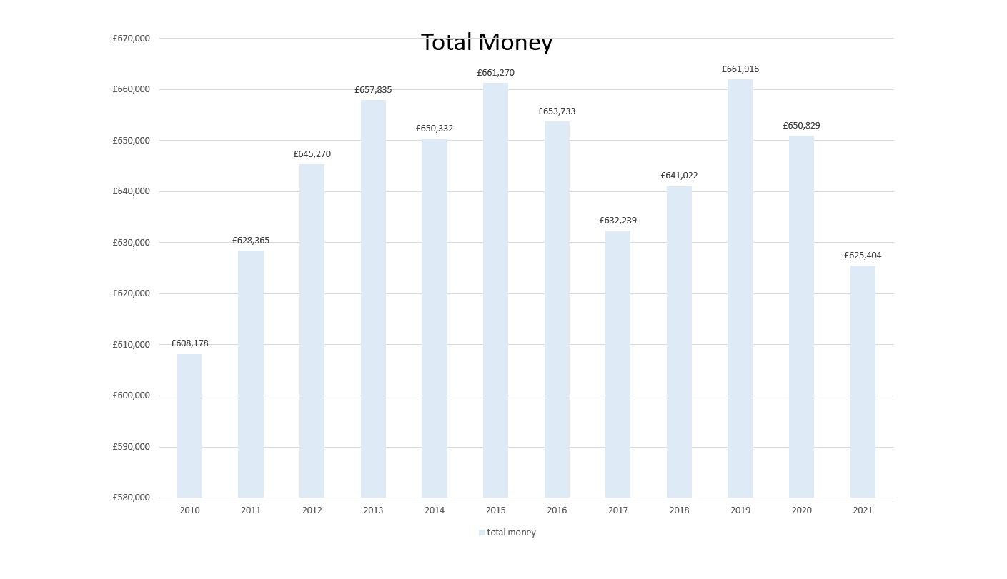
Slide 2

Slide 3
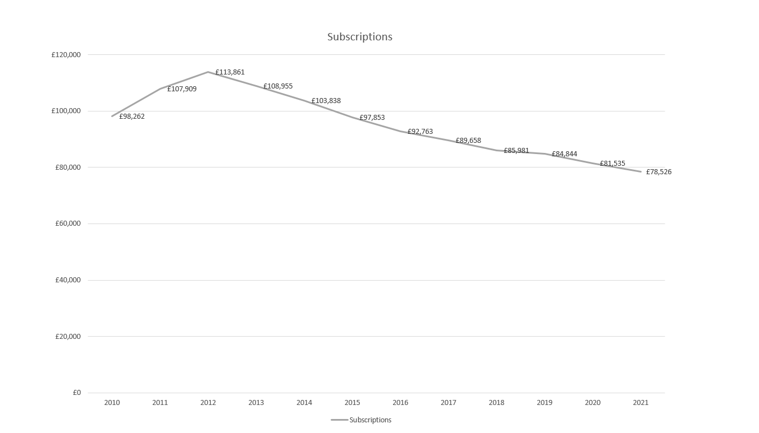

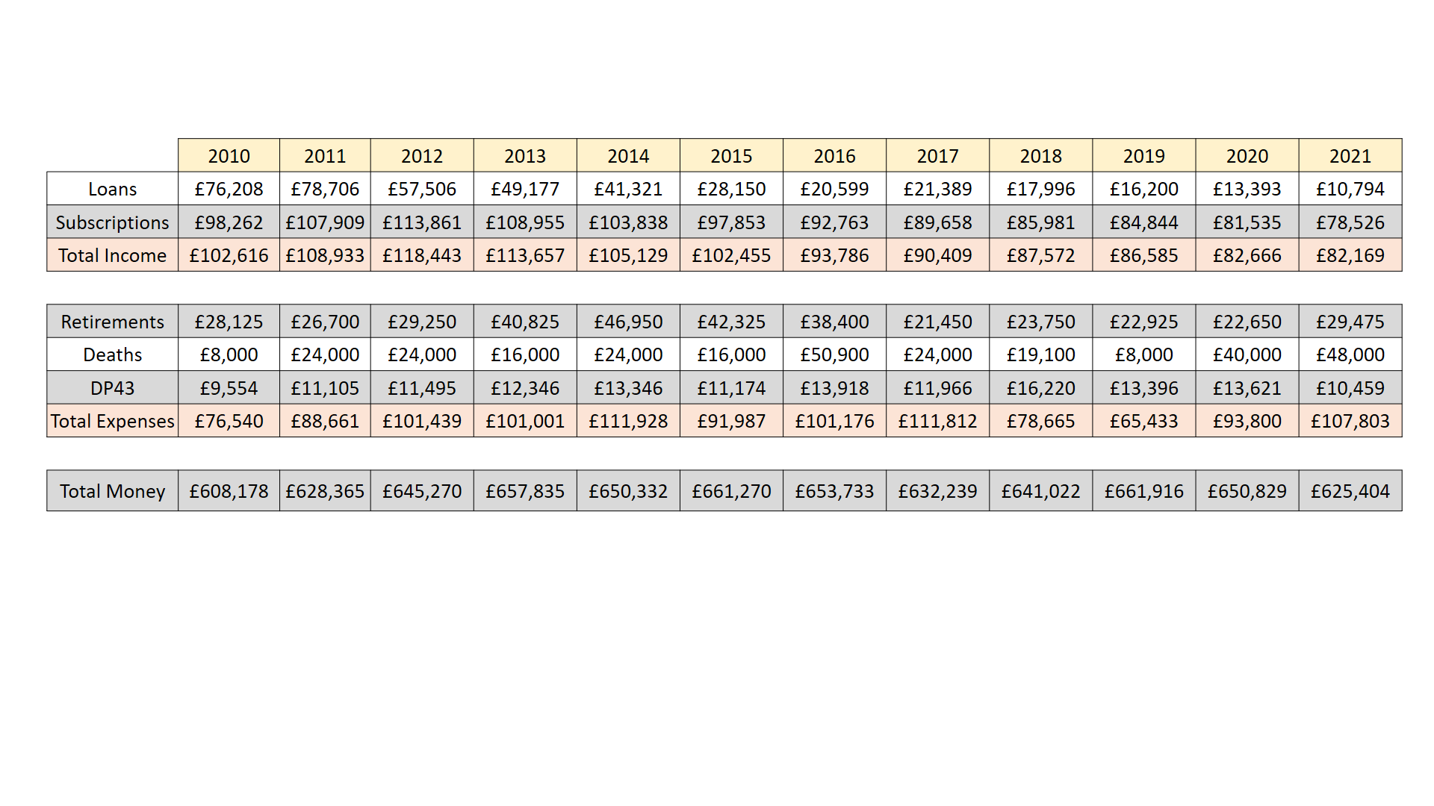
Slide 4
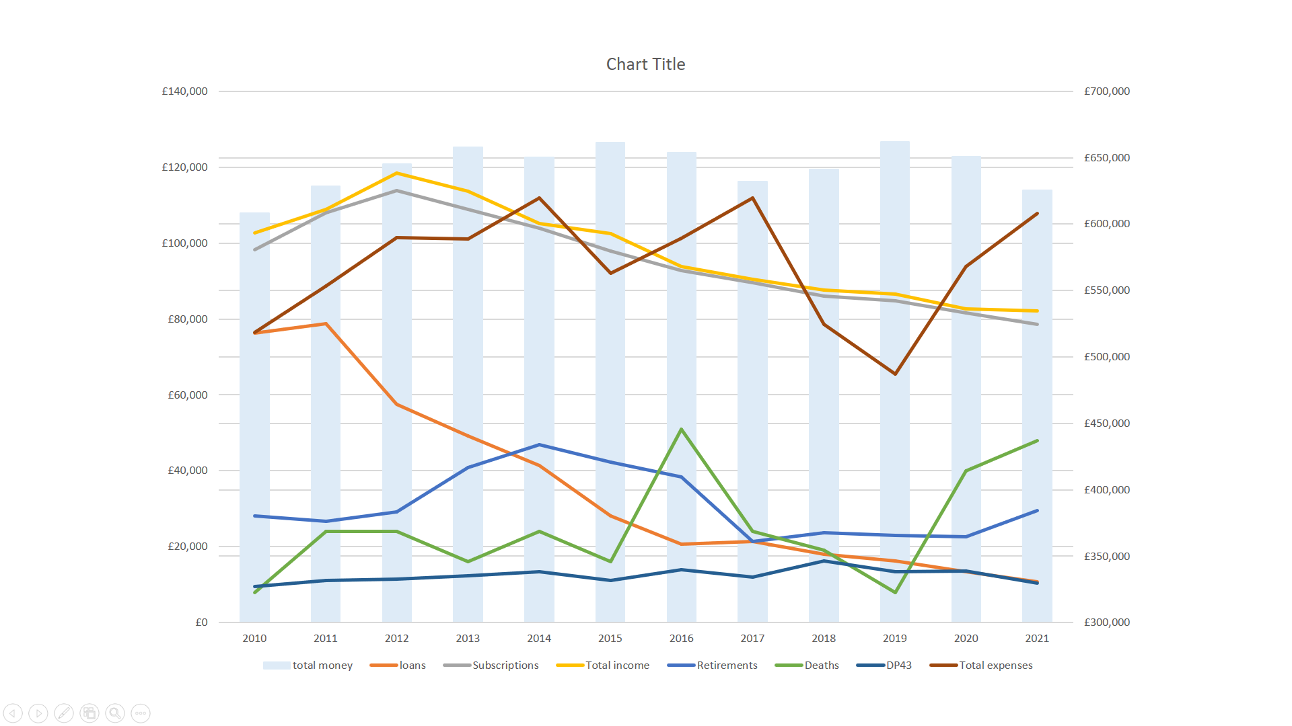
Slide 5
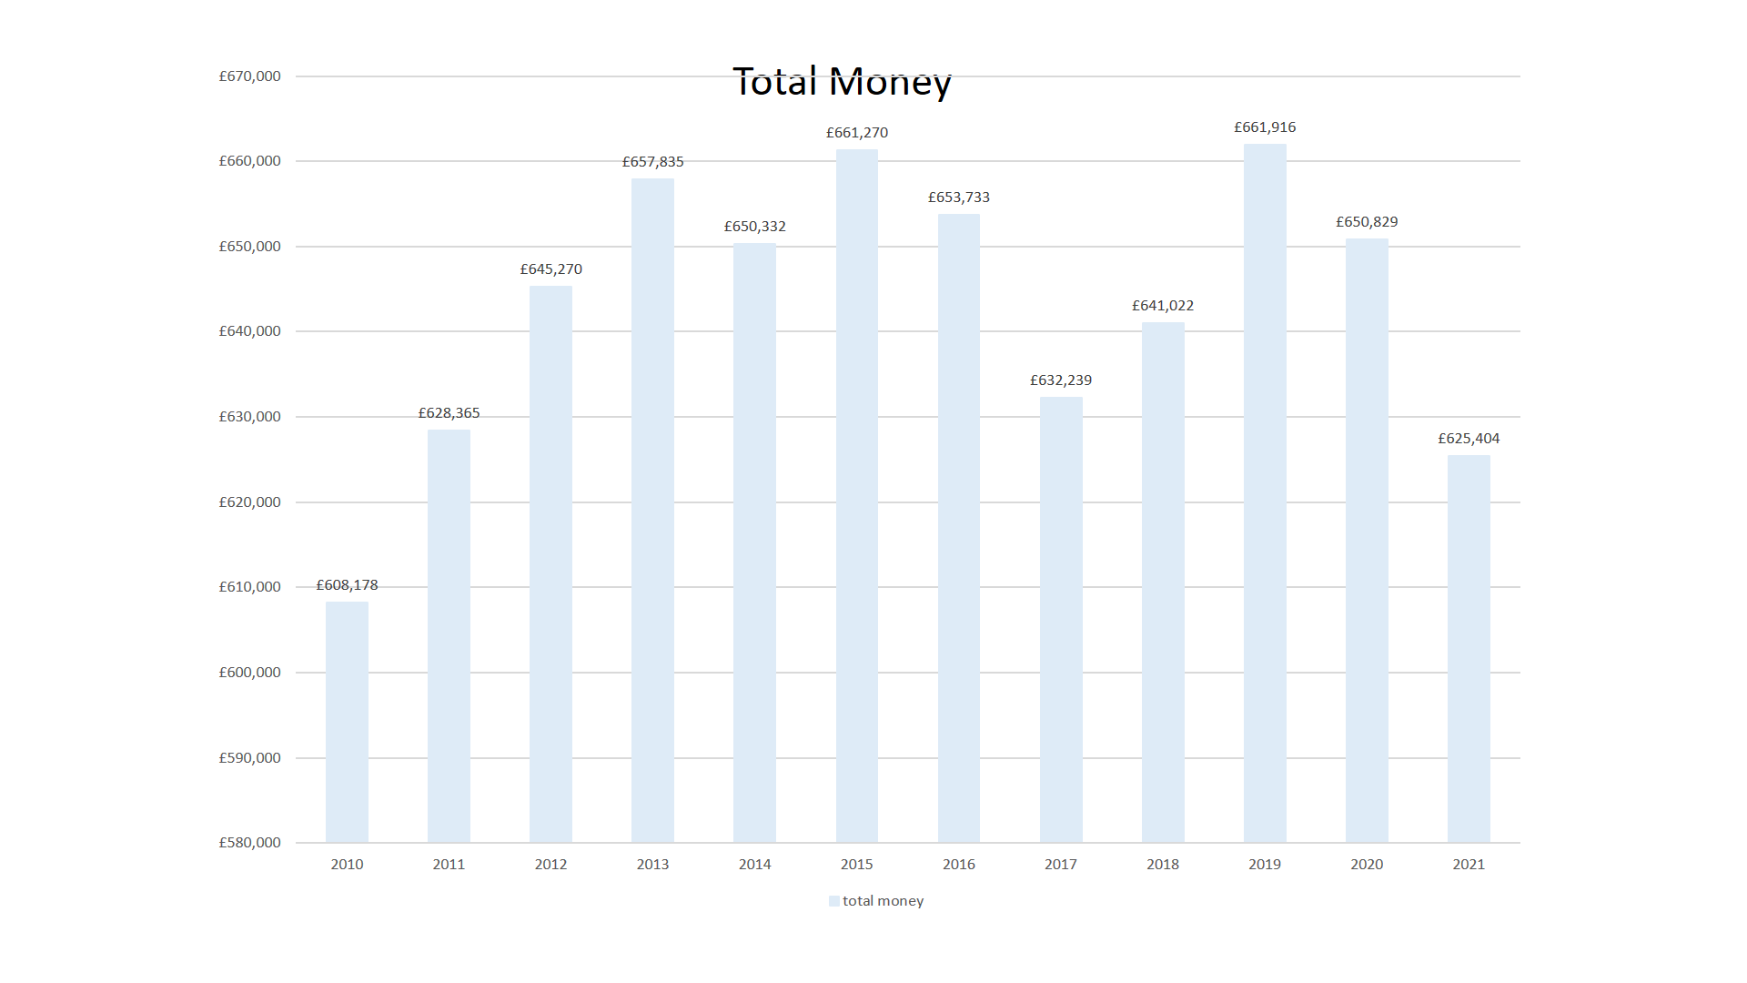
Slide 6
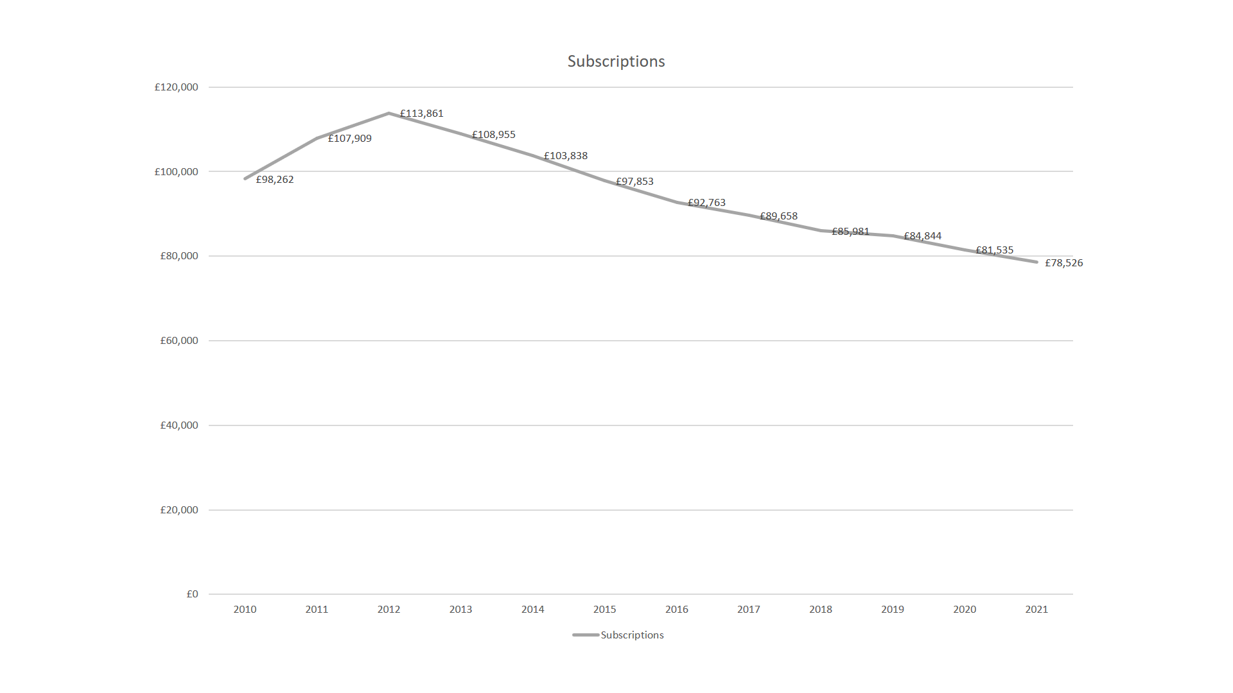
Slide 7
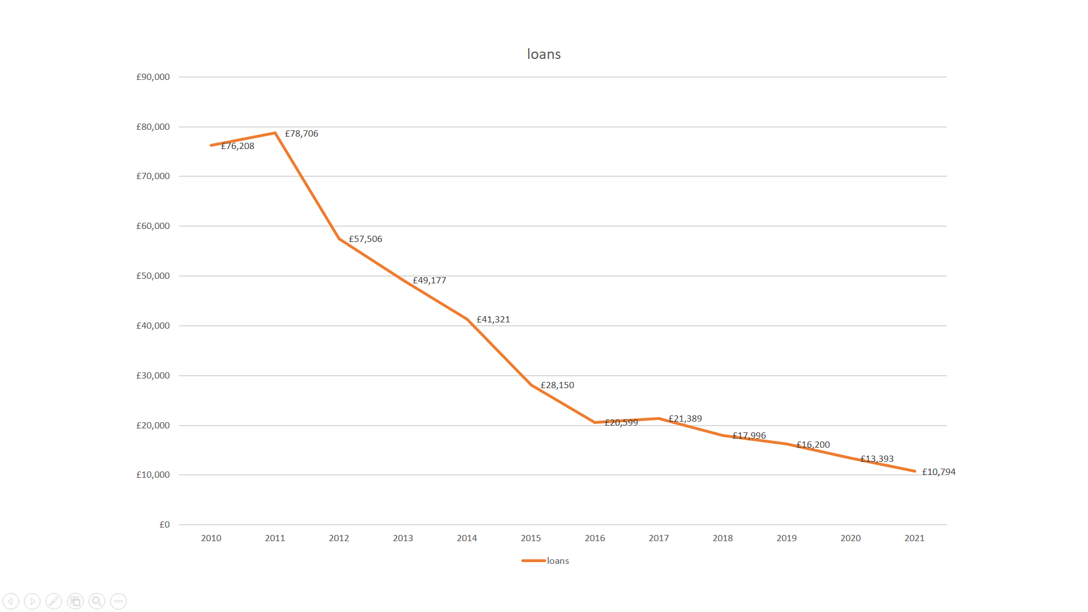
Slide 8
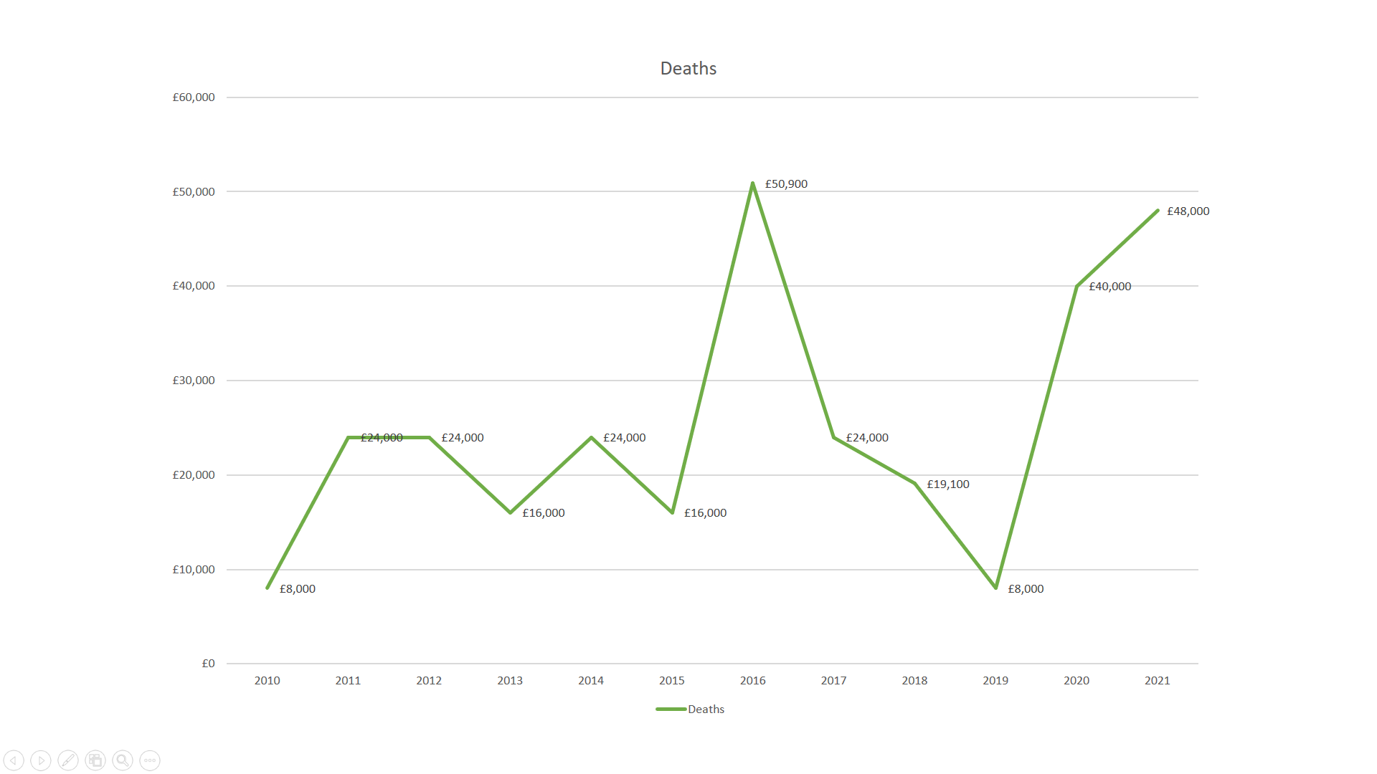
Slide 9
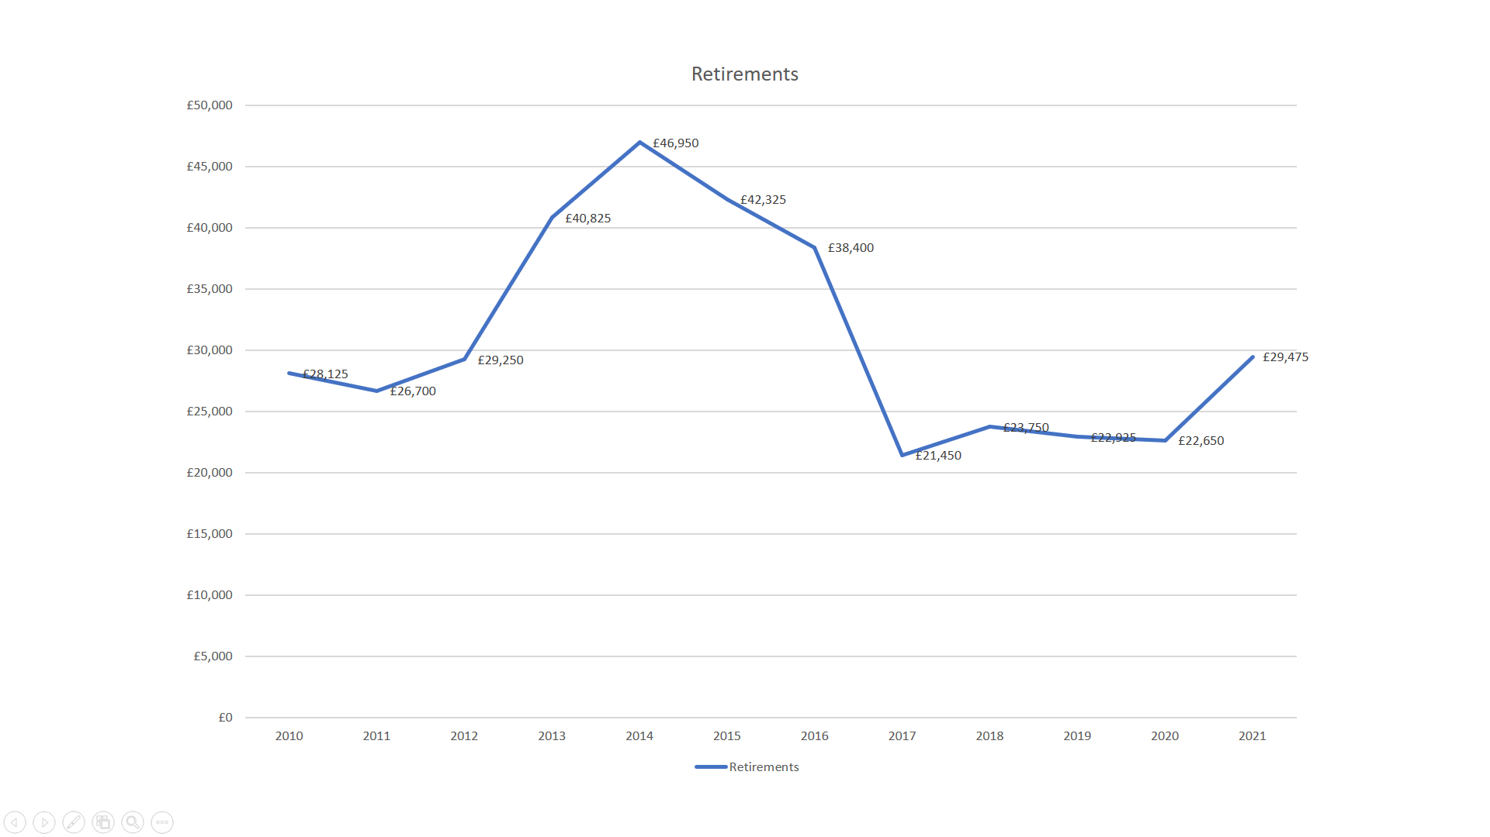
Slide 10
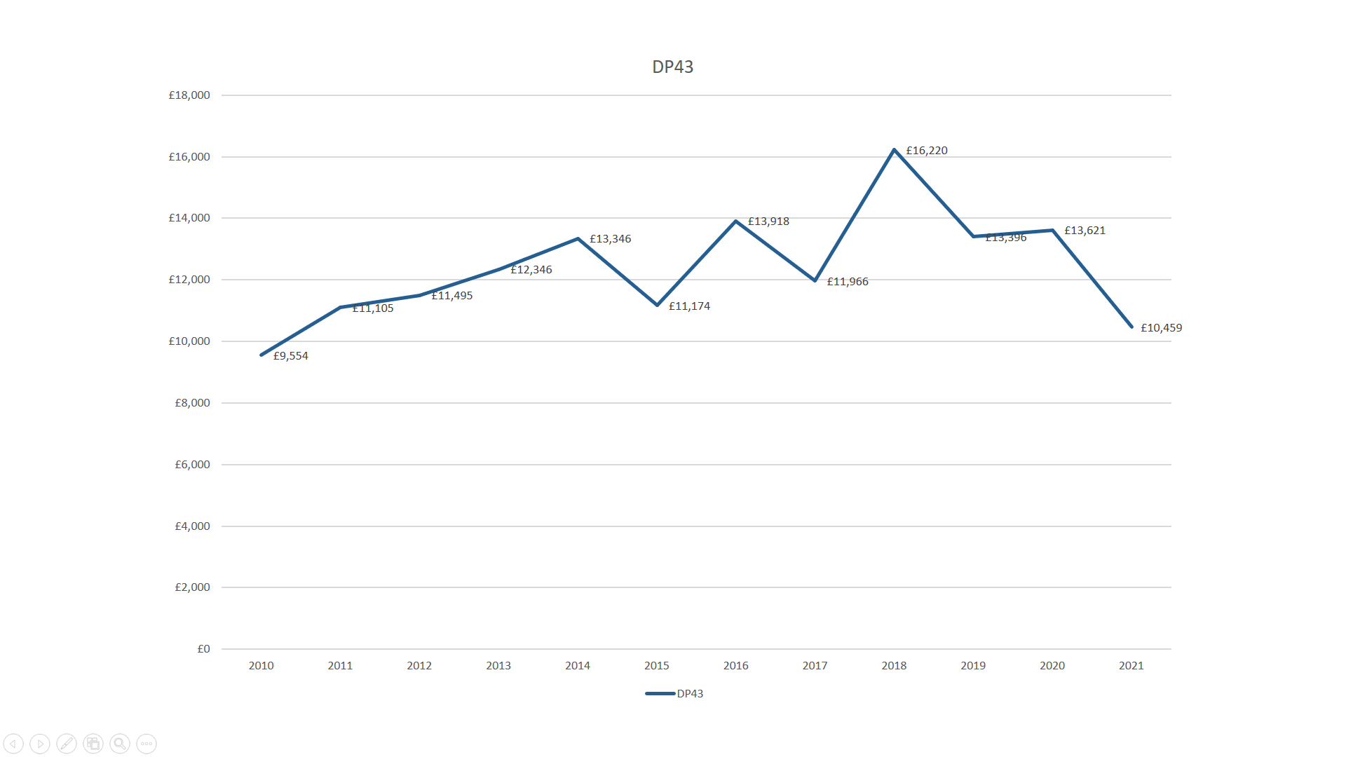
Slide 11
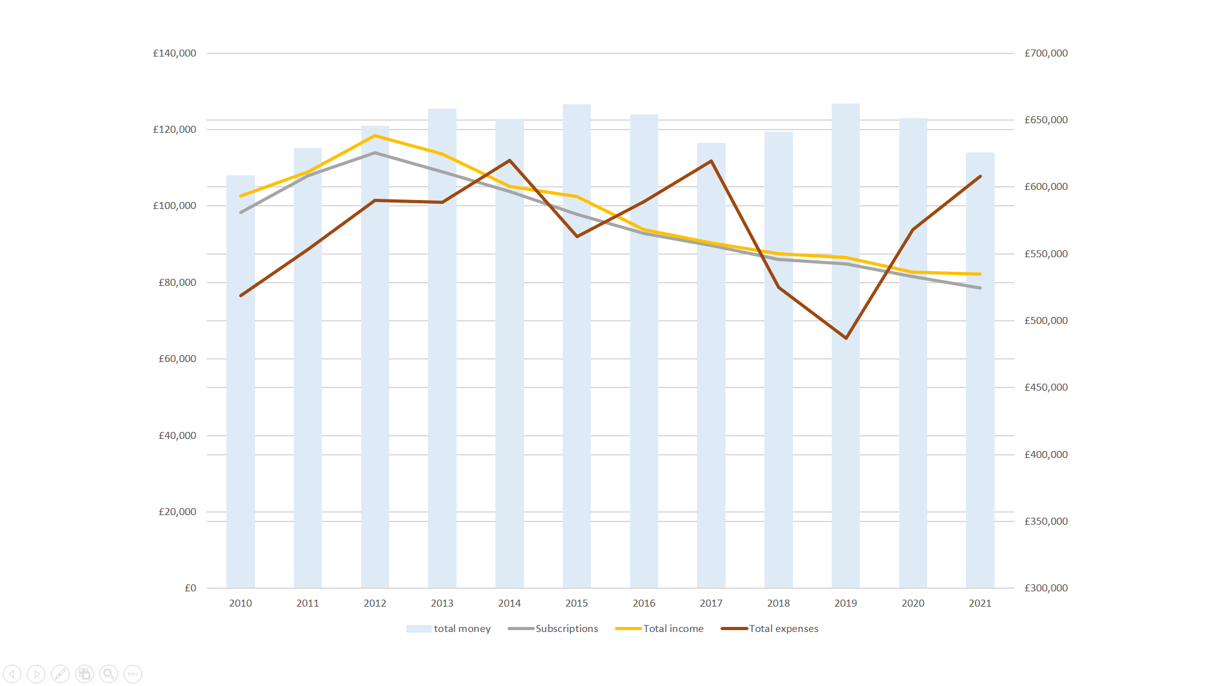
Slide 12

